**Population Genetics and the Forces of Evolution**

**Objectives**

Understand the forces of evolution, and be able to give examples of how alleles have changed under the forces of evolution

**Introduction**

**Population genetics** is the study of the distribution and changes in allele frequency within a population. An **allele** is a specific version of a **gene**. There may be many different types of alleles for a certain gene; people can have eyes that are blue, brown, green, or any combination in between, because there are many different types of alleles for eye color. A **genotype** is the alleles in one specific individual. For this lab, we are only considering species that are **diploid**, or have two alleles (humans and primates are diploid). For diploid species, a genotype will contain two alleles which may be the same or different. For example, we can have alleles *R* and *r*, and the possible genotypes are *RR*, *Rr*, and *rr*.

Population genetics is interested in allele frequencies because they are a simple way to characterize a population, but also because allele frequencies are central to the definition of evolution. **The most fundamental definition of evolution is a change in allele frequency over time.**

Such allele frequencies can be changed by the **four forces of evolution**:

1. Mutation
2. Selection
3. Genetic drift
4. Gene flow

Of course, these are not the only interesting things one can study in a population. There are other phenomena, such as non-random mating, that cause interesting patterns within a population, but do not actually change allele frequency in a population. For this lab, we are just concerned with the forces of evolution, which are anything that can cause a change in allele frequency.

**Exercises**

To better understand the forces of evolution, we will be doing several exercises that illustrate how allele frequencies change under different circumstances. For all exercises we will be using colored beads to represent our alleles. The red beads, **R**, will represent the dominant allele. White beads, **r**, will represent the recessive allele.

Divide into groups of 3-5 students. Each group will have a a set of pennies and a small pile of red and white beads. Each member of the group should take one penny and one bead. Try to have a roughly equal number of students in the group with red as with white beads. To complete the exercise, follow these steps:

1. Count the number of red beads in your group divide by the total number of beads. Record that number in the graph below at 'generation 0'
2. Everyone flips their coins.
   1. If your coin comes up heads, take another bead from the supply *of the same color as your current bead(s)*.
   2. If your penny comes up tails, return one bead to the supply. If you have no beads but any other member of your group has more than one bead, you may take a bead from the student with the most beads. If no one has more than one bead, you'll have to sit out until they do!
3. Count the number of red beads in your group and divide by the total number of beads. Record that number in the graph below at 'generation 1'
4. Repeat the above steps for each generation until one of the following happens:
   1. You have played out 6 generations
   2. All of the beads in your group are of the same color (the color has become “fixed”).
   3. There are no more beads in your group (your group has gone extinct! Sorry!)

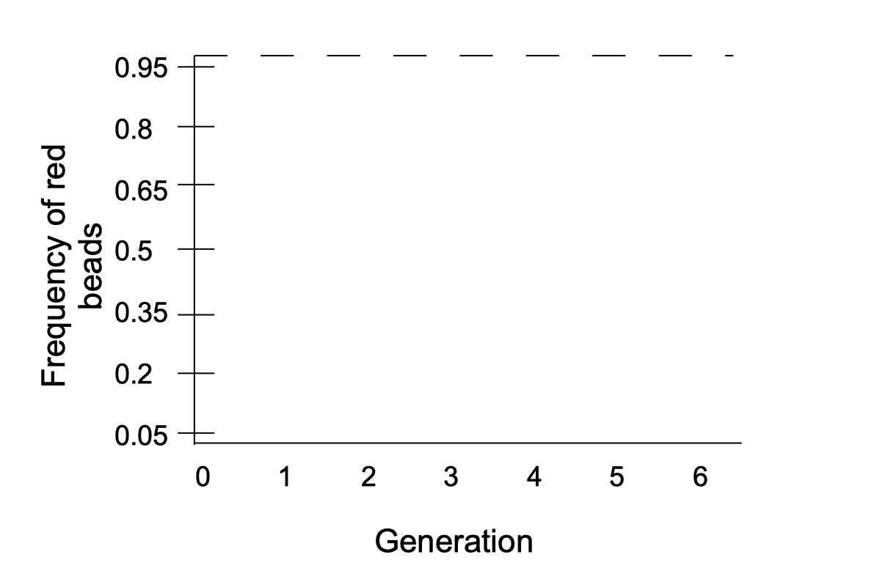

1. Describe the outcome of your trial. Did evolution happen? Did your population go extinct? Did either allele become fixed? Did you find this result surprising? Why or why not?

Now that you have a sense of how genetic drift works, we're going to use an app to experiment with different population sizes and to see what happens when selection gets involved. Go to one of the computers in the lab. You should see the following on your screen:

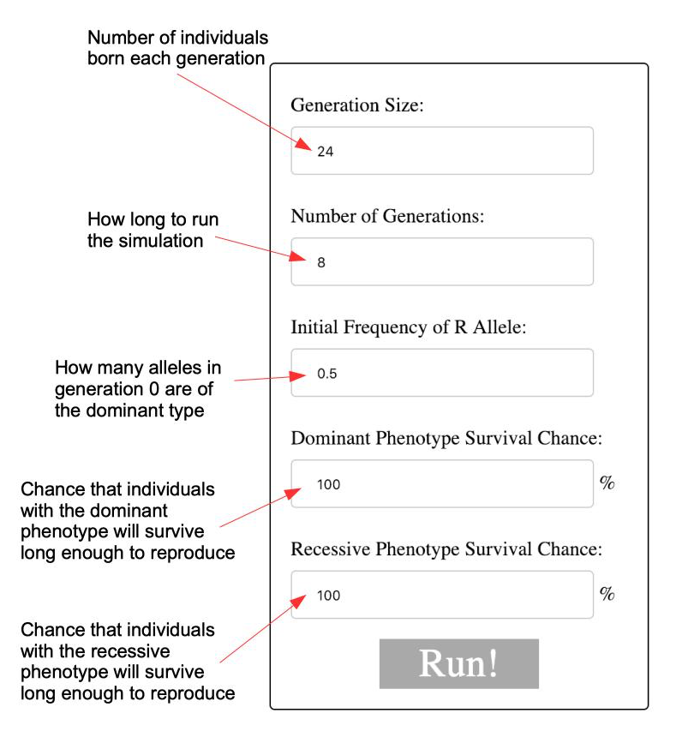

The app records the fate of a population with two alleles for a single gene: the dominant R and the recessive r. The allele frequency the app will show will be for the dominant R allele, but remember that the frequency of the recessive r allele is just 1 minus the frequency of the dominant R.

Set the generation size to 10 and the number of generations to 30. Let's set the survival rate to 50%. When you hit “Run,” you will get a result that looks something like this:

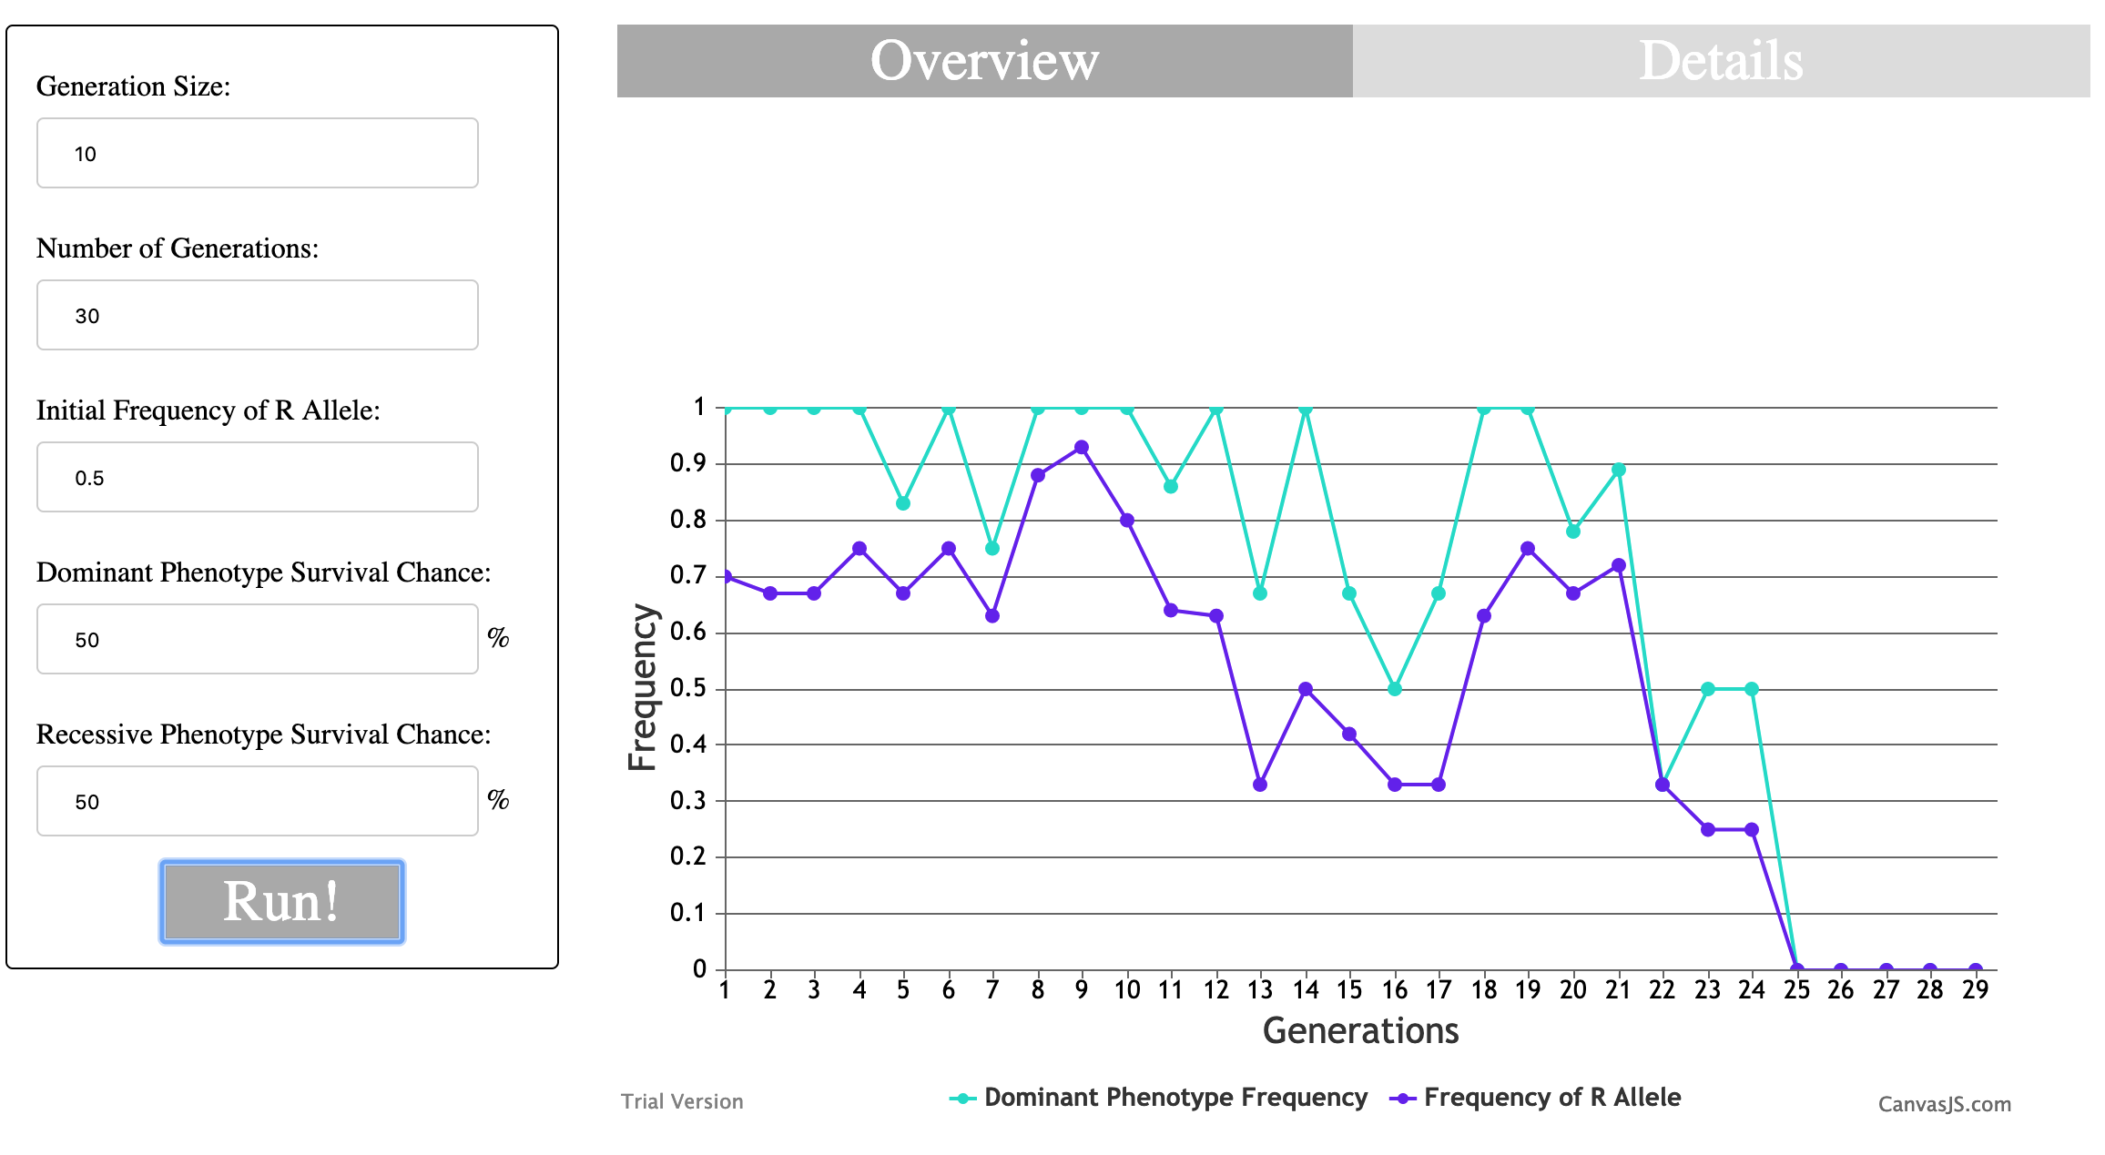The allele frequency (dark blue line) jittered up and down for a while, getting close to 1.0 for the R allele (and thus 0 for the r allele) around generation 9. But the r allele bounced back, and after another 15 or so generations of fluctuating, the r allele became fixed at generation 25 (the frequency of the R allele is at 0. Thus the frequency of the r allele is 1-0, or 1). Note that if you want you can take a look at the details of the population in the 'Details' tab. You'll see that there are no more R alleles starting at generation 25. Thus all offspring of all subsequent generations can only have the r allele.

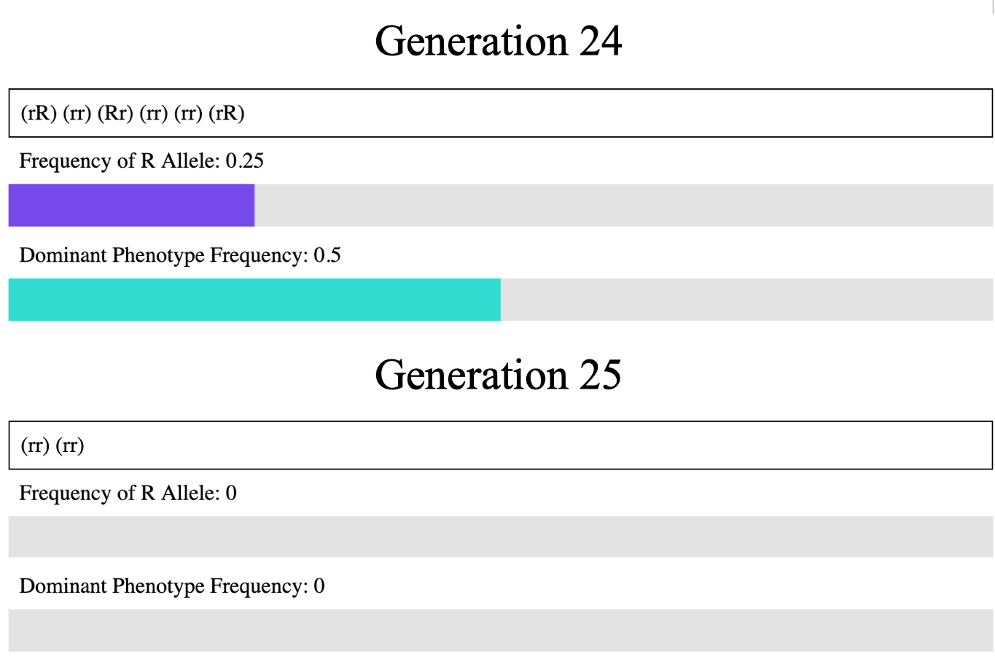

1. We have filled out the results of this first simulation for you. Run the simulation a few more times and fill out the results of each run in its own row of the table:

|  |  |  |  |  |
| --- | --- | --- | --- | --- |
| Simulation | Did either allele become fixed? (Y/N) | Which one? (r, R, or N/A) | At which generation? (Gen # or N/A) | How much variation between generations? (a lot, very little, etc) |
| 1 | Yes | r | 25 | A lot – up to 40% in one generation |
| 2 |  |  |  |  |
| 3 |  |  |  |  |
| 4 |  |  |  |  |
| 5 |  |  |  |  |

1. Can you recognize any trends in these simulations? Is there a particular outcome that seems more likely than the others? If so or if not, why do you think that might be?
2. Now let's see what happens if we increase the size of the population. Set generation time to 1000 and run the simulation a few more times, recording each in the table below.

|  |  |  |  |  |
| --- | --- | --- | --- | --- |
| Simulation | Did either allele become fixed? (Y/N) | Which one? (r, R, or N/A) | At which generation? (Gen # or N/A) | How much variation between generations? (a lot, very little, etc) |
| 1 |  |  |  |  |
| 2 |  |  |  |  |
| 3 |  |  |  |  |
| 4 |  |  |  |  |
| 5 |  |  |  |  |

1. Is the pattern different with a larger population? If so or if not, why do you think that is?

Now let's try adding selection into the mix. Increase the survival chance of the little r (recessive) phenotype to 55%.

1. Which *genotype*[s] are favored under this new selection regime?
2. Run the simulation 5 times and record your results in the (slightly modified) table below.

|  |  |  |  |  |  |
| --- | --- | --- | --- | --- | --- |
| Simulation | Did either allele become fixed? | Which one? | At which generation? | How much variation? | What was the allele frequency of r after the last generation? |
| 1 |  |  |  |  |  |
| 2 |  |  |  |  |  |
| 3 |  |  |  |  |  |
| 4 |  |  |  |  |  |
| 5 |  |  |  |  |  |

Now let's change the selection regime to favor the big R (dominant) phenotype. Move the survival chance of the recessive phenotype back to 50% and make the survival chance of the dominant phenotype up to 55%

1. Which *genotype*[s] are favored under this new selection regime?
2. Run the simulation 5 times and record the results in the (slightly modified) table below

|  |  |  |  |  |  |
| --- | --- | --- | --- | --- | --- |
| Simulation | Did either allele become fixed? | Which one? | At which generation? | How much variation? | What was the allele frequency of R after the last generation? |
| 1 |  |  |  |  |  |
| 2 |  |  |  |  |  |
| 3 |  |  |  |  |  |
| 4 |  |  |  |  |  |
| 5 |  |  |  |  |  |

1. Did you notice any difference between selection favoring the recessive phenotype and selection favoring the dominant phenotype? If so or if not, why do you think this is? (hint: note that the light blue bar on the graph represents the 'phenotype frequency' for the dominant phenotype. Think about how it relates to the allele frequency, and why it has that relationship).
2. Now let's try with selection but a smaller population. Set the generation size back down to 10. Leave the survival chance of the dominant phenotype at 55% and the survival chance of the recessive phenotype at 50%, so that the dominant phenotype has a selective advantage. Run the simulation five more times and record your results.

|  |  |  |  |  |  |
| --- | --- | --- | --- | --- | --- |
| Simulation | Did either allele become fixed? | Which one? | At which generation? | How much variation? | What was the allele frequency of R after the last generation? |
| 1 |  |  |  |  |  |
| 2 |  |  |  |  |  |
| 3 |  |  |  |  |  |
| 4 |  |  |  |  |  |
| 5 |  |  |  |  |  |

1. Based on these results, do you think selection was the main factor driving evolution of this population? If so, is it similar to or different than the pattern seen with a larger population? If not, what other force of evolution is likely driving the evolution seen here? Why might this be?
2. Now choose your own parameters and try to run the simulation again. What parameters did you choose? What was the result? If you ran this test multiple times, do you think the result would be similar to what you observed? Briefly justify your answer. [IMPORTANT NOTE: the simulation can take a long time to run if you have too many generations. We recommend keeping the number of generations below ~100, which should take about 10-15 seconds.]
3. In this lab we looked at the effect of genetic drift and selection and how these two forces of evolution can drive evolution in different circumstances. Why do evolutionary biologists care about genetic drift?